Analysis of Alnwick Awnings System Dynamics

Report ( Causal Loop Diagram )
Understand how operations, marketing, demand, and capacity investment interact to shape performance and sustainability.
Relationships between the variables and their effects :-
- Number Of Sales Reps ———→ (+) Orders Per Month
- Orders Per Month ———→ (+) Order Backlog
- Capacity Per Month ———→ (+) Order Fill Rate
- Percentage Utilization ———→ (+) Order Fill Rate
- Pressure On Production ———→ (-) Percentage Utilization
- Order Backlog ———→ (+) Pressure On Production
- Average Price Per Month ———→ (-) Orders Per Month
- Reported Sales Revenue ———→ (+) Marketing Budget
- Average Order Fill Rate ———→ (+) Reported Sales Revenue
- Order Fill Rate ———→ (+) Average Order Fill Rate
- Time To Average Order Fill Rate ———→ (-) Average Order Fill Rate
- Marketing Budget ———→ (+) Required Sales Representative
- Required Sales Rep ———→ (+) Gap (Hire/Fire)
- Gap (Hire/Fire) ———→ (+) Hire/Fire Rate
- Time Taken To Hire/Fire ———→ (-) Hire/Fire Rate
- Order Backlog ———→ (+) Delivery Delay
- Order Fill Rate ———→ (-) Delivery Delay
- Recognized Delivery Delay ———→ (-) Orders Per Month
- Hire/Fire Rate ———→ (+) Number Of Sales Reps
- Delivery Delay ———→ (+) Recognized Delivery Delay
- Time To Recognize Delivery Delay ———→ (-) Recognized Delivery Delay
- Delivery Delay Recognized By The Factory ———→ (+) Delivery Delay Condition
- Delivery Delay Operating Goal ———→ (-) Delivery Delay Condition
- Time For Factory To Recognize Delivery Delay ———→ (-) Recognize Delivery Delay By Factory
- Capacity Per Month ———→ (+) Capacity Order Rate

- Capacity Expansion Fraction ———→ (+) Capacity Order Rate
- Capacity Per Month ———→ (+) Capacity Expansion Fraction
- Delivery Delay Pressure ———→ (+) Capacity Expansion Fraction
- Delivery Delay Condition ———→ (+) Delivery Delay Pressure
- Delivery Delay Bias ———→ (-) Delivery Delay Pressure
- Capacity Order Rate ———→ (+) Capacity Being Built
- Capacity Order Rate ———→ (+) Capacity Per Month
- Number Of Sales Reps ———→ (+) Orders Per Rep
- Orders Per Rep ———→ (+) Order Per Month
- Time To Recognize Delivery Delay Tradition ———→ (-) Delivery Delay Tradition
- Delivery Delay Management Goal ———→ (+) Delivery Delay Operating Goal
- Delivery Delay Tradition ———→ (+) Delivery Delay Operating Goal
- Price per Order ———→ + Reported Sales Revenue
- Sales rep salary ———→ - Required sales reps
- Backlog Of Orders ———→ + Order Fill Rate
- Capacity ———→ - Pressure On Production
- Number Of Sales Reps———→- Gap
- Order Fill Rate———→- Backlog Of Orders
- Percentage To Marketing———→ + Marketing Budget
- Rep Salary ———→ - Required Number Of Reps
- Price Per Order ———→ - Order Rate
- Delivery Delay ———→+ Delivery Delay Recognized by Factory
- Capacity Arrival Rate———→+ Capacity
- Delivery Delay Weight———→+ Delivery Delay Operating Goal

CAUSAL LOOP DIAGRAM

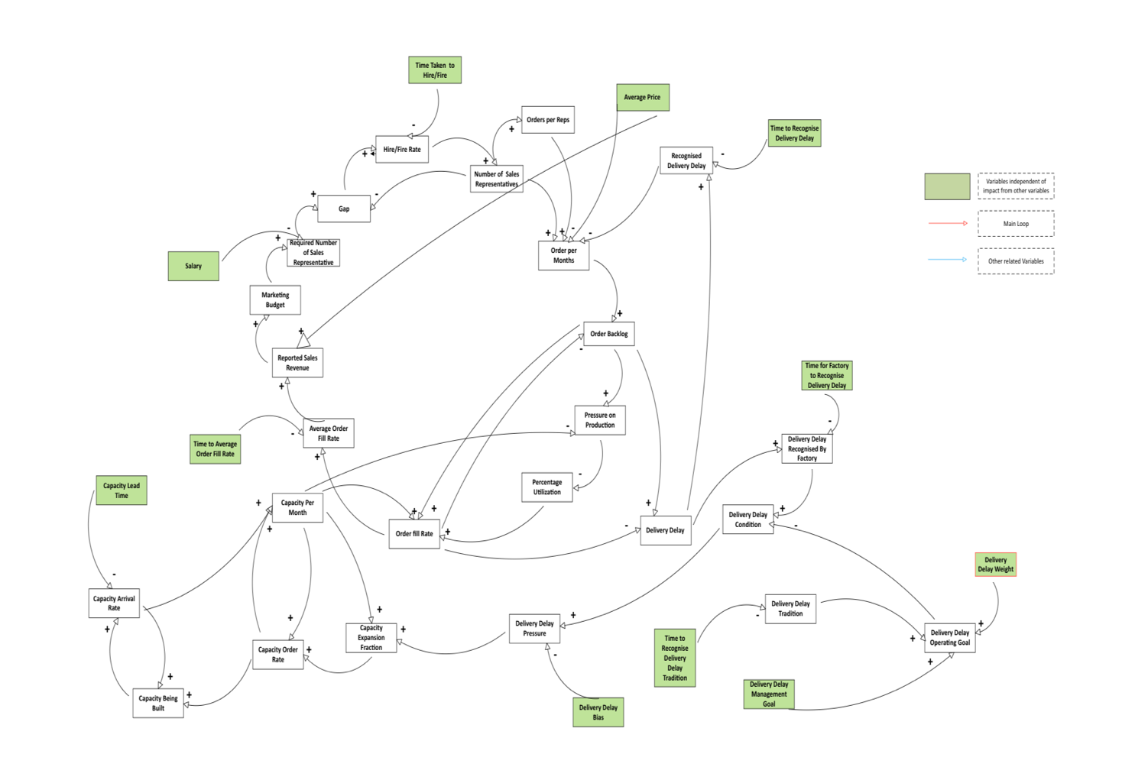

The causal loop diagram illustrates the complex interconnected system driving Alnwick Awnings' business operations. Six primary feedback loops and create the dynamic behaviour of this growing manufacturing company.
The sales engine operates through reinforcing loops, where reported sales revenue drives marketing budget allocation (14% of revenue), determining required sales representatives. With each rep generating approximately 7 orders monthly, this creates a powerful growth mechanism when the gap between required and actual reps is positive, triggering hiring (though delayed by a 6-month hiring/training process).

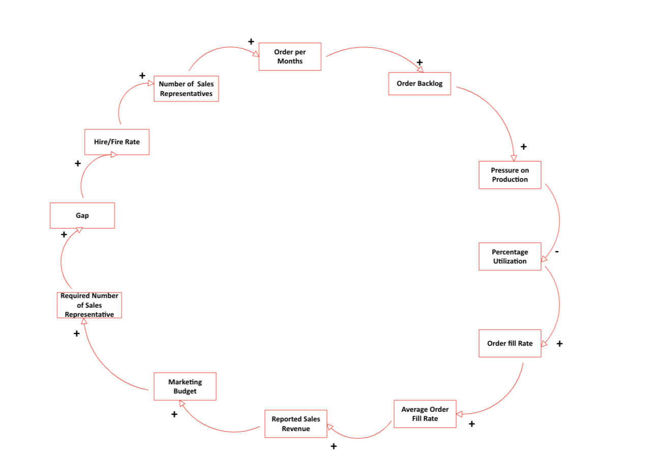

Production capacity constraints create balancing mechanisms. CLD show how increasing order backlog extends delivery delays, eventually causing customers to reduce orders after a 4-month recognition period. The production system responds through increased utilization (90 orders/month capacity), helping to process backlog. 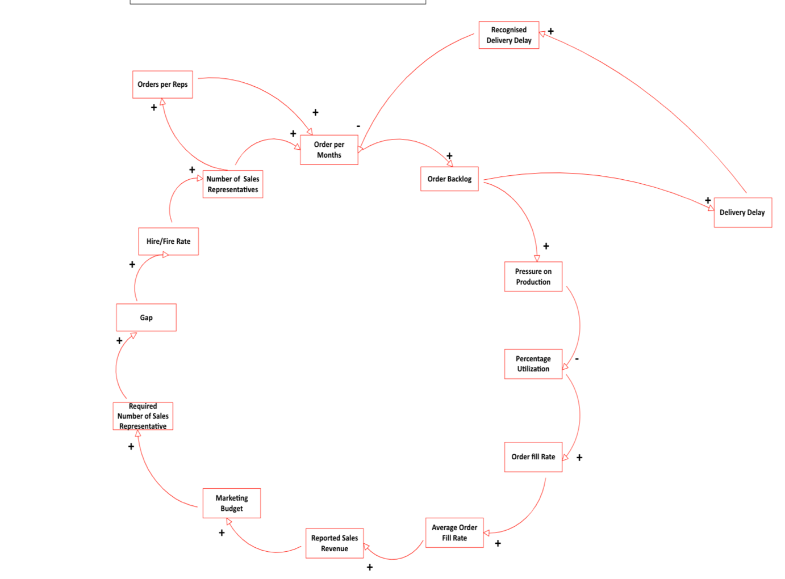

The capacity investment mechanism illustrates how capacity expansion decisions depend on recognized delivery delays compared to operating goals. The conservative bias (0.3) from ownership (particularly Peter) slows expansion decisions, while the 12-month capacity acquisition lead time creates significant delays in responding to demand growth.

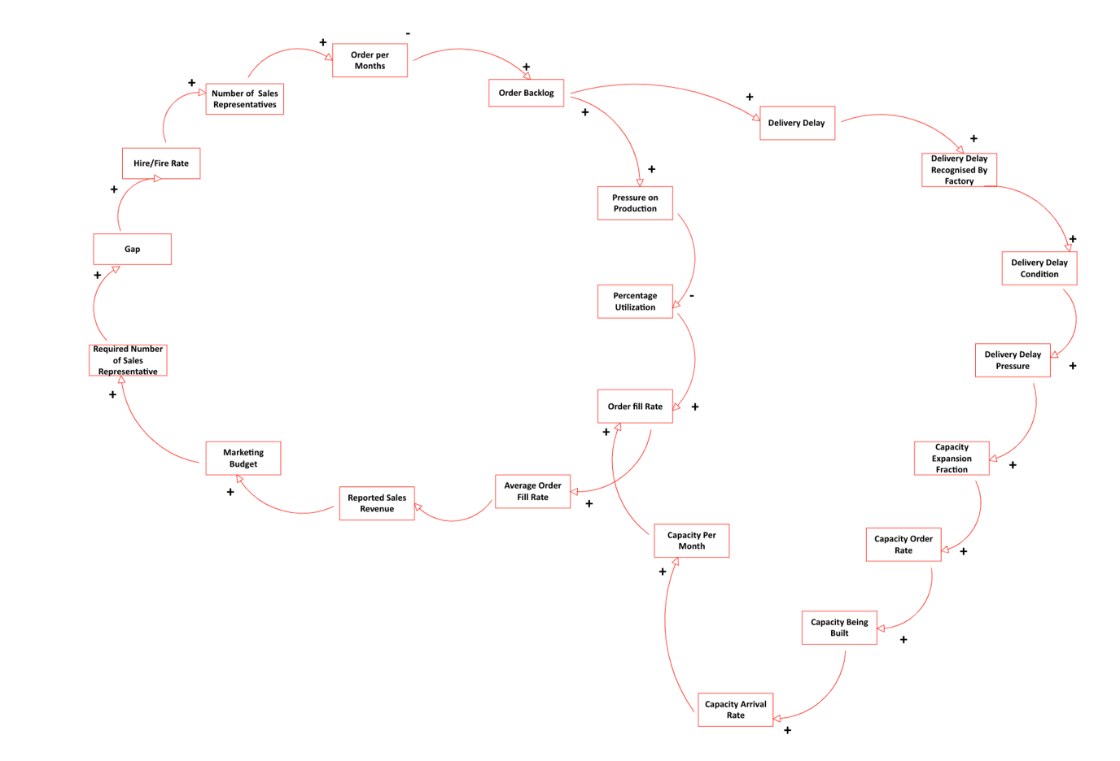

Other loop demonstrates how delivery delay goals adapt over time, currently weighted heavily toward historical performance (Delivery Delay Tradition) rather than fixed management targets.
The interaction between these loops creates classic growth-and-constraint behavior. The sales engine continually generates demand while capacity constraints create periodic bottlenecks, leading to delivery delays that temporarily suppress demand. This dynamic is exacerbated by the conservative capacity expansion policy and multiple time delays throughout the system (in hiring, capacity building, and customer perception).

